**Design Thinking Project Workbook**

**Don't find customers for your product but find products for your customers**

# Team

**Team Number=16**

**Team Logo:**

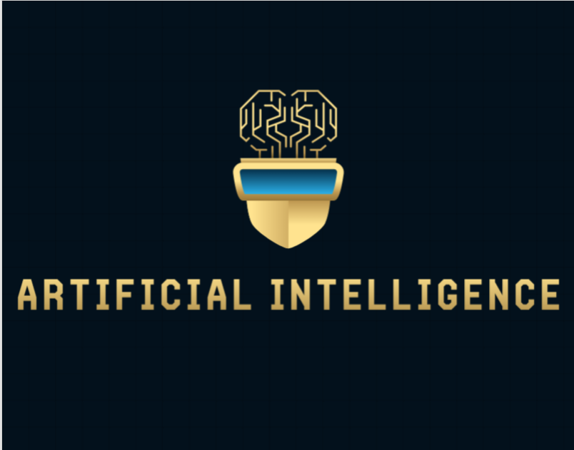

**Team Members:**

1. T.Sai Jaswanth – 2320030445
2. M.Dinesh – 2320030452
3. T.Rishi - 2320030444
4. C.Niraj - 2320030480

# Problem/Opportunity Domain

**Domain of Interest: Natural Language Processing (NLP) and Machine Learning**

**Description of the Domain: The domain focuses on processing and analyzing large volumes of text data using machine learning techniques to develop models for language prediction, translation, sentiment analysis, and more. Key challenges include handling multilingual datasets, improving model accuracy, and efficiently processing data in real-time.**

**Why did you choose this domain?: We’re really into AI and machine learning, and it just seemed like a cool way to make a real difference. Plus, with everyone talking to people from all over the world, there’s a huge need for tools that can handle different languages easily. So, we figured, why not jump in and see what we can do?**

# Problem/Opportunity Statement

**Problem Statement: Many applications require accurate and efficient identification of the language of a given text input to enable further processing, such as translation or sentiment analysis. Current methods may lack the accuracy or speed needed for seamless integration into diverse applications.**

**Problem Description: The challenge is to develop a machine learning-based interpreter that can predict the language of a text input with high accuracy, enabling improved performance in multilingual applications.**

**Context (When does the problem occur): The problem typically occurs in scenarios where applications must handle text inputs from multiple languages, such as in global customer service platforms, social media monitoring, or language translation services.**

**Alternatives (What does the customer do to fix the problem): Customers might use existing language detection APIs or rely on manual language selection, which may not be accurate or efficient enough for dynamic, real-time applications.**

**Customers (Who has the problem most often): Organizations providing multilingual services, developers of global applications, and users of translation tools.**

**Emotional Impact (How does the customer feel): Frustration due to inaccurate language detection, leading to poor user experience or miscommunication.**

**Quantifiable Impact (What is the measurable impact): Time wasted in correcting language misidentifications, financial costs from inefficient workflows, and potential loss of customers due to poor user experience.**

**Alternative Shortcomings (What are the disadvantages of the alternatives): Existing solutions may lack the adaptability, accuracy, or scalability required for certain applications, leading to increased costs and inefficiency.**

# Addressing SDGs

**Relevant Sustainable Development Goals (SDGs):**

* **Goal 9: Industry, Innovation, and Infrastructure**
* **Goal 10: Reduced Inequalities**

**How does your problem/opportunity address these SDGs?: By developing an accurate language prediction interpreter, the project supports innovation in technology (Goal 9) and enables broader access to multilingual communication tools, thereby reducing inequalities in communication (Goal 10).**

# Stakeholders

1. **Who are the key stakeholders involved in or affected by this project?**

Developers, end-users, companies providing multilingual services, AI researchers.

1. **What roles do the stakeholders play in the success of the innovation?**

Developers implement and refine the technology, end-users provide feedback, companies invest in and deploy the solution, and researchers contribute to continuous improvement.

1. **What are the main interests and concerns of each stakeholder?**
   * Developers: Creating efficient and accurate solutions.
   * End-users: Ease of use and reliability.
   * Companies: ROI and market competitiveness.
   * Researchers: Advancing the field and publishing findings.
2. **How much influence does each stakeholder have on the outcome of the project?**
   * High: Developers and Companies
   * Medium: End-users
   * Low: Researchers
3. **What is the level of engagement or support expected from each stakeholder?**

High engagement from developers and companies; moderate from end-users; low from researchers.

1. **Are there any conflicts of interest between stakeholders? If so, how can they be addressed?**

Potential conflicts could arise between developers focusing on innovation and companies prioritizing cost-efficiency. Address by aligning goals through regular communication.

1. **How will you communicate and collaborate with stakeholders throughout the project?**

Regular meetings, progress reports, feedback sessions, and collaborative platforms like Slack or Teams.

1. **What potential risks do stakeholders bring to the project, and how can these be mitigated?**
   * Developers: Technical challenges. Mitigate through R&D and prototyping.
   * Companies: Budget constraints. Mitigate through phased development.
   * End-users: Adoption resistance. Mitigate through user-friendly design and education.

# Power Interest Matrix of Stakeholders

**Power Interest Matrix: Provide a diagrammatic representation of Power Interest Matrix**

|  |  |
| --- | --- |
| **Keep Satisfied** • Investors | **Manage Closely**   * Developers * Companies |
| **Monitor**  • Researchers | **Keep Informed** • End-users |

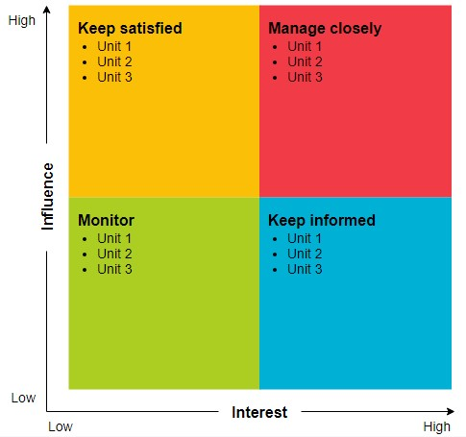

* High Power, High Interest: Developers, Companies
* High Power, Low Interest: Investors
* Low Power, High Interest: End-users
* Low Power, Low Interest: Researchers